

**PIMSAT Employee Information System**

A Project Study

Presented to the Faculty of the College

of Information Technology Binalatongan Community College

In Partial Fulfillment

of the Requirements for the Degree

BACHELOR OF SCIENCE IN INFORMATION TECHNOLOGY

By:

Lazaga,Mar R.

Ambanloc,Maurine S.

Aguilar,Alondra G.

Gallardo,John Paul G.

January 2023

Chapter 1

**Introduction**

**Background of the Study**

In this technology-driven age, successfully managing the human resource is one key to an effective operation of any organization with the aim of achieving certain objectives and goals. The ever changing trend in technology brought the necessity for the automation of everything from paper-and-pen based to absolute computer domination. The overwhelming emergence of computers paved way to easier access of information that leads to increased production, efficiency and reliability. This is achievable with information systems for proper identification of potential employee down to the efficient management and tracking of employee database. Organisations in this age and time must of necessity rely on information to flourish and thrive. That is why we proposed the Employee Information System for the **PIMSAT College**. It is a kind of program that can store,add,edit information of an employee in an easy way. This school is located in Rizal Ave.,Poblacion, San Carlos City,Pangasinan is a private,non-sectarian educational institution were every student does pay for their tuition fees and offer different courses.

**Encountered Problems**

* The problem they encounter is that they use manual recording system for their employee.
* Manual recording is time consuming and have a risk in storing data.
* Searching and tracking of information becomes complex and time consuming. This system is important to the school because it will help them managing the manual process of their employee. Thereby increasing the efficiency and decreasing workload. This project helps to maintain the details of the employee that can be easily accessed anytime and the data can be kept safely for a long period of time.

PIMSAT Colleges was established in January of 1983. The founder is Dr./Atty. Rebene C. Carrera – Chairman of the Board,and Chief Executive Officer of the said Colleges in all branches. He was born on March 24,1951 and died January 29,2022. The current President of the schoool is his daughter Maria Cristina Angela Carrera-Lusanta . PIMSAT Main Branch is located at McArthur Highway,Bolosan District,Dagupan City,Pangasinan. The school has vision,mission,goals and objectives. **Vision** – Accelerator of Scientific and Technological Advancement for the Realities of the Future. In short: A STAR of the FUTURE. **Mission** – The Institution shall Strengthen its Presence in the International Market of Science Applcations and Tecnology. In short: Strengthen PIMSAT. **Goals & Objectives** : Offer programs to unleash the people’s potentials and community resources for productivity; Train students in the application of technology for the benefit of the people and communities. Apply innovative and technologically oriented instructional delivery systems for economical and effective learning by its clients. Develop competencies in the process of research and development and the effective use of its results; and Strengthen its linkage with business and industry through partnerships and collaborative complementation.

**Hypothesis**

There are two proposed hypothesis in this research. They are Null Hypothesis (Ho) and the Alternative Hypothesis (Ha).

* Ho: There is no significant relationship of using Information system and the employee to their work.
* Ha: There is significant relationship of using Information system and the employee to their work.

**Importance of the Study**

This study will help on every employee that they can maintain the time management. And this new system will bring about efficient and effective managing about the employee information.

This study will be beneficial to the following:

**Admin** – the Admin will be the one who manage the information of the employee in the system so that they can minimize their workload.

**Employee** – the system will be very important to the employee because anytime they can attendance or file a leave of absence. They can also see if their request are approve or disapprove.

**School** – the school will be the one to greatly benefit from this system.

**Objectives of the Study**

Main objective of the system is to develop an  Employee Information System for PIMSAT. Furthermore, the developers aim to achieve the following specific objectives:

1. To identify the existing process of employee information system such as filing of leave of absence,Attendace and Application.

2. To identify the features of the system for the following users:

* Employee can submit their Attendance and file for leave of absence through the system.
* The admin can check the system and the information of the employee that are submitted.
* The admin can approve or disapprove the leave of absence of the employee.

3. To perform the following test to the system.

* Acceptability Test

To test the acceptability of the system, developer needs to test the employee information system if it is stored or record the employee information,the attendance, and if can approved or disapproved the employee leave of absence application.

* User Test

The test should be evaluated in the user’s perspective, if the system that the developers created is working properly or not..

4. Develop a well-designed database to store employee information.

6. Easy retrieval of employee information.

**Definition of terms**

**Automation -** is a term for technology applications where human input is minimized.

**Competencies** - is a set of demonstrable characteristics and skills that enable, and improve the efficiency of, performance of a job.

**Database** - is information that is set up for easy access, management and updating. They collect information on people, places or things.

**Employee** – a person employed for wages or salary, especially at nonexecutive level.

**Identification** - the action or process of identifying someone or something or the fact of being identified.

**Information System** – is a combination of software, hardware, and telecommunication networks to collect useful data

**Manual Process** - involve one or more humans performing tasks, such as data entry and/or verification

**PIMSAT** – Philippine Institute for Maritime Studies and Technology

**Organization** - an organized body of people with a particular purpose, especially a business, society, association, etc.

**Program** - a series of coded software instructions to control the operation of a computer or other machine.

**Proposed** – to suggest a plan

**Technology** - refers to methods, systems, and devices which are the result of scientific knowledge being used for practical purposes.

**Review of Related Literature**

**Local**

* Maggay J. (2017),

Based on the study of Maggay J.(2017) regarding Biometric Attendance Monitoring System of Cagayan State University. The goal of the study is to develop a fully customized Biometric Attendance Monitoring System (BAMS) of Cagayan State University – Lasam Campus, Philippines (CSU - Lasam) using a biometric fingerprint reader to facilitate the monitoring of employees’ attendance. Thus, the overall functionality of the BAMS enables the users to enter data, change and manipulate the data, get information, and store the data and the information. Username and password is no longer needed since all transactions use a unique fingerprint to validate users. Furthermore,the BAMS greatly contributes in giving employees’ ease and improving work values. Likewise, the BAMS is essential in achieving good governance because it helps track day-to-day attendance of the employees.

* S. Sosa, D. D. (2017),

In today’s competitive environment, computerization or automation of the business process is of considerable importance because many people believe that with the help of this technology most organizations can make their operational, tactical, and strategic processes more productive, effective and efficient. Management information system (MIS) is the means of support of any business organization today and the functionality of information systems is a necessity.

* Nicolas De Jesus(2019),

The Provincial Government of Bulacan's Human Resources Office (PHRMO) is responsible for,among other services, the maintenance of records associated with payroll preparation and processing. They are also responsible for maintenance of 201 files for each individual employee. Among the significant services brought about by the PHRMO through the use of HRIS, on top of the list is the fast and accurate processing of pertinent employee records like service records and payroll. Through the automatic computation facility and integrated time keeping system,processing time to determine leave credits, which is necessary for computation of pay of employees who have absences, and processing time to prepare remittances for GSIS, PAG-IBIG, and MEDICARE are very well addressed. This system did not only empowered the employees and increased their productivity, but also became a tool to eliminate red tape. Through HRIS, response time to employee requests is admirable.

**Foreign**

* Niati et al., 2021,

Human Resources (HR) is the most important component in a company or organization to run the business it does. Organization must have a goal to be achieved by the organizational members.

* According to Arisandy, Harpepen and Kurniawan (2017),

the primary purpose of a human resource information system is to increase efficiency and reduce manual writing activities, but with an automated system and the availability of information, it will be much better. This opinion is in line with Dewi (2013) that with the existence of a human resource information system, it will be more efficient in saving time, and costs, and is accurate and quickly processed. Implementing human resource information systems will create a good company and increase shareholder value, because managers have more time to design strategies, and time is not wasted on administrative tasks such as record keeping.

* According to the article of Maramis and Rompas (2018),

regarding the RFID based Employee Attendance Management System, manually recorded attendance of all the employees has produced some problems such as the data accuracy and staff performance efficiency. The objective of this research is to design and develop a software of RFID attendance system which is integrated with the database system. This RFID attendance system was developed using several main components such as tags that will be used as a replacement of ID cards and a reader device that will read the information related to the employee attendance. The result of this project is a software of RFID attendance system that is integrated with the database and has a function to store the data or information of every single employee. This system has a maximum reading range of 2 cm with success probability of 1 and requires a minimum interval between readings of 2 seconds in order to achieve an optimal functionality. By using the system, the discipline attitude of the employees and also the performance of the staff will be improved instantly.

Chapter 2

**Methodology**

**Software Development Methodology**

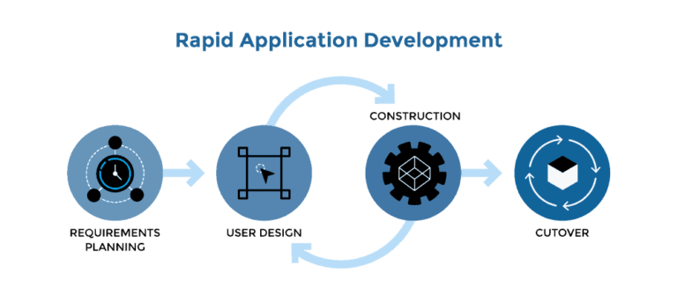

The developers chose the RAD methodoloy because RAD focuses more on ongoing software projects and user feedback and less on following a strict plan. As such, it emphasizes rapid prototyping over costly planning. We consider also using this methodology for the fact that it should be used when there is a need to create a system that can be modularized in 2-3 months of time,so its really suits to us as a first time developer. Additionally the developers chose this methodology because it reduced development time, increases reusability of components, quick initial reviews occur, encourages customer feedback, integration from very beginning solves a lot of [integration issues](http://tryqa.com/what-is-system-integration-testing/).

**Rapid application development (RAD)** is an agile project management strategy popular in software development. The RAD model is a form of agile methodology that focuses on constant iterations and prototypes based on user feedback. It allows you to incorporate updates based on usage rather than a rigid development plan. It is more adaptive approach to software development. While regular plan-based methods require a rigid structure with specific requirements. A RAD  approach  is based around flexibility and the ability to adapt alongside new knowledge.

Due to its flexibility and adaptability to new inputs, a RAD approach carries far less risk than a basic plan based method. With an early prototype, it is fairly easy to identify any key challenges associated with the project. As such, RAD weeds out any potential problems early on in the life-cycle, making it cheaper and easier to  address during development. As a direct result, RAD projects typically take a shorter time to complete.

RAD allows project managers and stakeholders to effectively monitor progress and communicate in real time on emerging issues or adjustments by decreasing planning time and prioritizing prototype iterations. As a result, there is more efficiency, quicker development, and better communication.

Here are four fundamentals steps that  are still applicable in RAD models today:

**Phase 1. Requirements Planning**

In this phase, all the relevant members (managers, IT staff, users, etc,) plan and agree on the project’s needs, scope, challenges, and requirements. What makes RAD different from other models in this regard is that it sets broad requirements  to stay flexible over time.

A basic breakdown of this stage involves:

* Researching the current problem
* Defining the requirements for the project
* Finalizing the requirements with each stakeholder’s approval

It is important that everyone has the opportunity to evaluate the goals and expectations for the project. Groups can avoid miscommunications and costly modification orders down the line by obtaining approval from each important stakeholder and developer.

**Phase 2. User design**

Once the project is scoped out, it’s time to jump right into development, building out the user design through various prototype iterations.

In this phase, the users work with developers to create and develop one or more prototypes that cover the outlined system requirements. This continuous phase wherein the users interact with the prototype and provide feedback until a true final product is approved.

**Phase 3. Construction**

This is the other continuous  phase and works hand-in-hand with user input. This step focuses on implementing the feedback provided by the users through coding,testing, and any other applicable development tasks. The 2nd and 3rd phases feed into each other until the users approve the product. The phase breaks down into several smaller steps:

* Preparation for rapid construction
* Program and application development
* Coding
* Unit, integration, and system testing

During this phase software development team of programmers, coders, testers, and developers will need to sure everything and work on hand to the user to ensure that they can met their expectations.

The construction phase is important it is because the user still gets to provide input during the process. They can recommend alterations, changes, or even new thoughts that can solve problems and complications as they arise.

**Phase 4. Cutover**

In this phase,once the product is eventually approved,developers put some finishing touches in the form of testing ,conversion,interface, or user training. Once the product is properly assessed for factors like stability and longevity, it is ready to be delivered.

All final deviations are made while the users and coders will continue to find for bugs in the system.

**SCOPE & DELIMITATION**

The scope of the Employee Information System are:

* The system can manage Employee Information.
* It can approve and disapprove the leave of absence.
* It can manage attendance of the employees.
* The employee can view and update its information.
* The admin can manage and view information.

**Delimitation**

* The system cannot notify the Employee or users thru text messages
* It cannot correct human error
* Cannot be use in Payroll management

**Data Gathering Techniques**

The developers used Interviews, it is one-on-one conversations to explore ideas, opinions, values or other points of view. It is the developers used when gathering information regarding on the PIMSAT Employee Information System. Interviews are particularly useful to; Investigate issues in depth,it allows us for face-to-face contact and observing behavior, it allows us exploring and clarifying opinions, or dealing with the unexpected, it helps us engage participants in the TNA process, and helps us explore / confirm other data / information (for example, the information obtained from documents). We also used the observations,and internet research.

**Interviews** – is a accurately defined as a formal meeting between two individuals in which the interviewer ask the interviewee questions in order to gather information. The interviewer ask questions, the interviewee responds,with participants taking turns talking.

**Observations** – the observation method of data collection involves seeing people in a certain setting or place at a specific time and day. This data collection method does not require researcher’s technical skills when it comes to data gathering.

**Internet research**– we used internet to gather information about employee information system. We use google,wikipedia, Google Scholar ,Microsoft Academic,etc.

**Sources of Data**

Dr. Art G. Tangco – College Dean(PIMSAT)

Ms. Doria A. Umagtam – School Nurse and Record Officer

[PIMSAT Colleges, Inc. - San Carlos City (wikimapia.org)](http://wikimapia.org/10250917/PIMSAT-Colleges-Inc)

<https://www.lucidchart.com/blog/rapid-application-development-methodology>

<https://www.bircu-journal.com/index.php/birci/article/view/6170/pdf>

<https://www.researchgate.net/profile/PiyushmAgnihotri/publication/327883688_RFID_Technology_Based_Attendance_Management_System/links/5bab414592851ca9ed25f5a8/RFIDTechnology-Based-Attendance-Management-System.pdf>

<https://iopscience.iop.org/article/10.1088/1757-899X/306/1/012045/meta>

<https://asrjetsjournal.org/index.php/American_Scientific_Journal/article/view/3278>

<https://zenodo.org/record/345444#.Y3nJJ8dBzIU>

<https://www.academia.edu/5653216/Local_Literature>

Solen, M. E. & Sajorda, M. G.. (2014). EMPLOYEE INFORMATION SYSTEM: IMPROVING QUALITY CONTROL OF EMPLOYEE RECORDS. BENCHMARK: College of Business Research Journal, 2(1). Retrieved from http://ejournals.ph/form/cite.php?id=10422

Arisandy, Y., Harpepen, A., & Kurniawan, A. (2017). Sistem Informasi Manajemen (Teori dan Implementasi dalam Bisnis) (A. Sunarto (ed.)). Pustaka Pelajar.

Chapter 3

**Discussion of Findings**

The developers use the flowchart to illustrate the existing process of employee information system such as filing of leave of absence,Attendance and Application.

A flow chart is a graphical or symbolic representation of a process. Each step in the process is represented by a different symbol and contains a short description of the process step. The flow chart symbols are linked together with arrows showing the process flow direction.

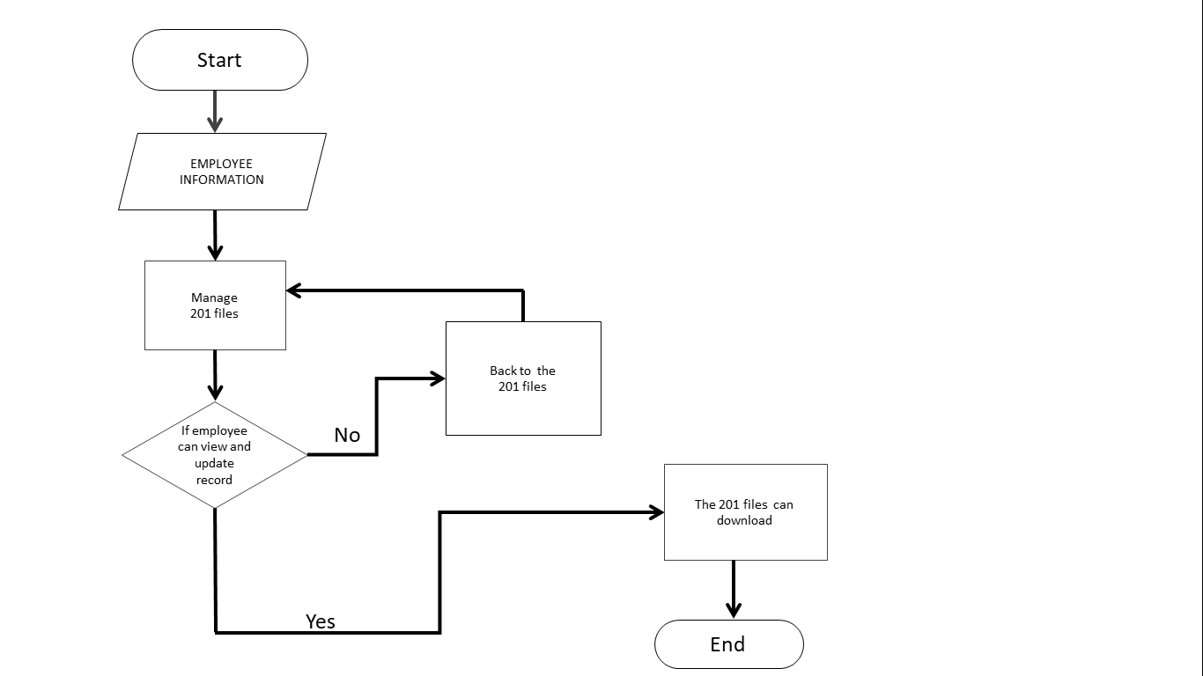

The flowchart shows the process and step where the Employee will manage their 201 files. The employee will check their 201 files if they can view or update their record. If No the employee will back to the 201 files and try again. If it  is Yes, the employee can check it to their account that the 201 files can be downloadable.

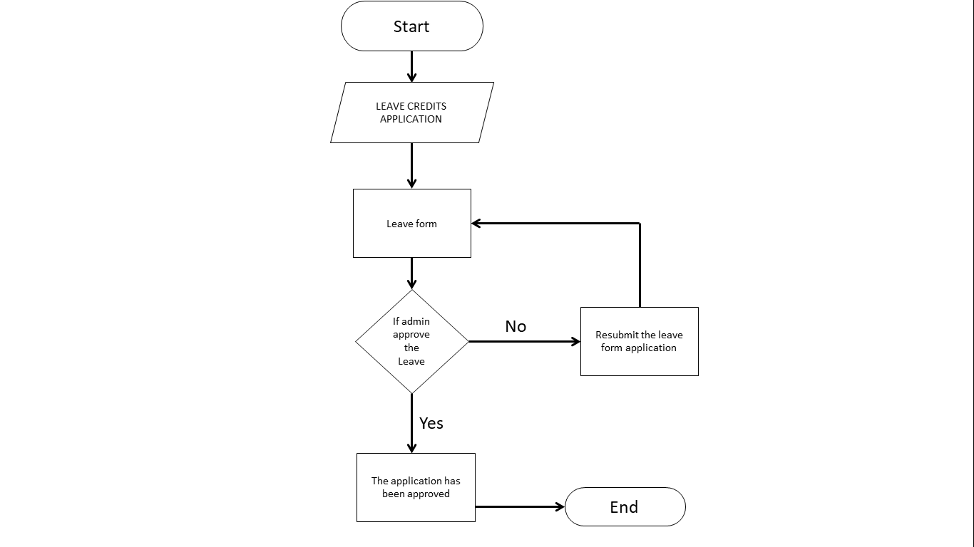

The flowchart shows the process and step of leave credits application. The admin will check the employee application for leave of absence and decide if it is approved or disapproved. If disapproved the employee will resubmit the leave form application and try again. If it  is approved, the employee can check it to their account that the leave application has been approved.

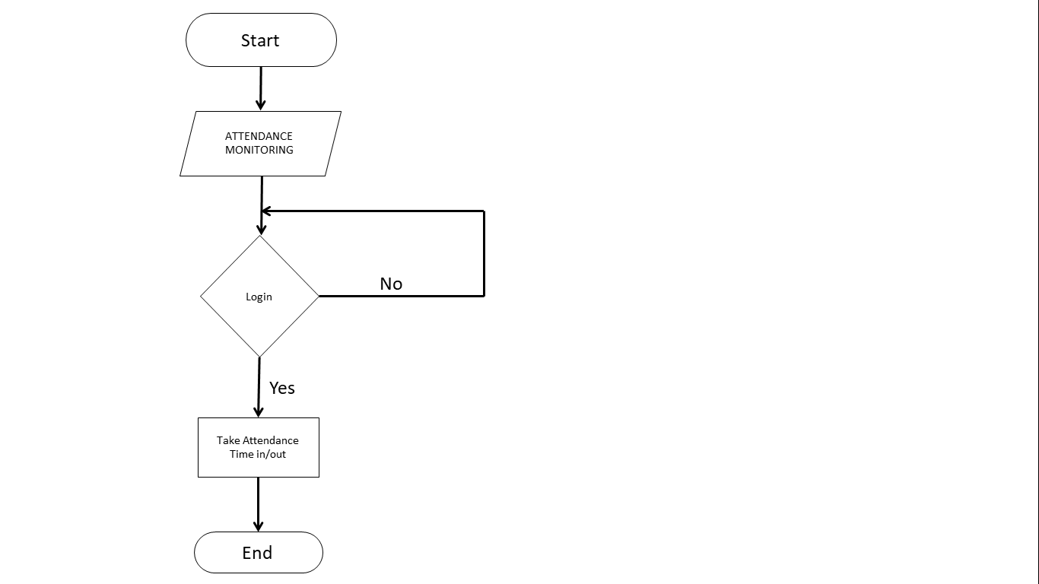

The flowchart shows the process and step of attendance monitoring where the Employee will login in the system enter their information and data,fill up the attendance form for time in/out in order to have their attendance.

**Features of the System**

**Employee**

Features for the employees,

Employee’s Profile, Change Password, Attendance, Apply Leave, Leave History

**Admin**

Features for the Admin,

Dashboard, Manage Attendance, Manage Leave Type, Manage Employee, All Leaves of absence,Pending,Approved,Cancelled Leaves,Add,Edit,Delete,Update, Login and Logout

**System Design**

**Conceptual design(IPO)**

The part of the design process where-by categorizing the essential problems through abstraction, establishing functions structure, searching for appropriate working principles and uniting these into a working structure—the basic solution path is laid down through the elaboration of a solution.

**CONCEPTUAL FRAMEWORK**

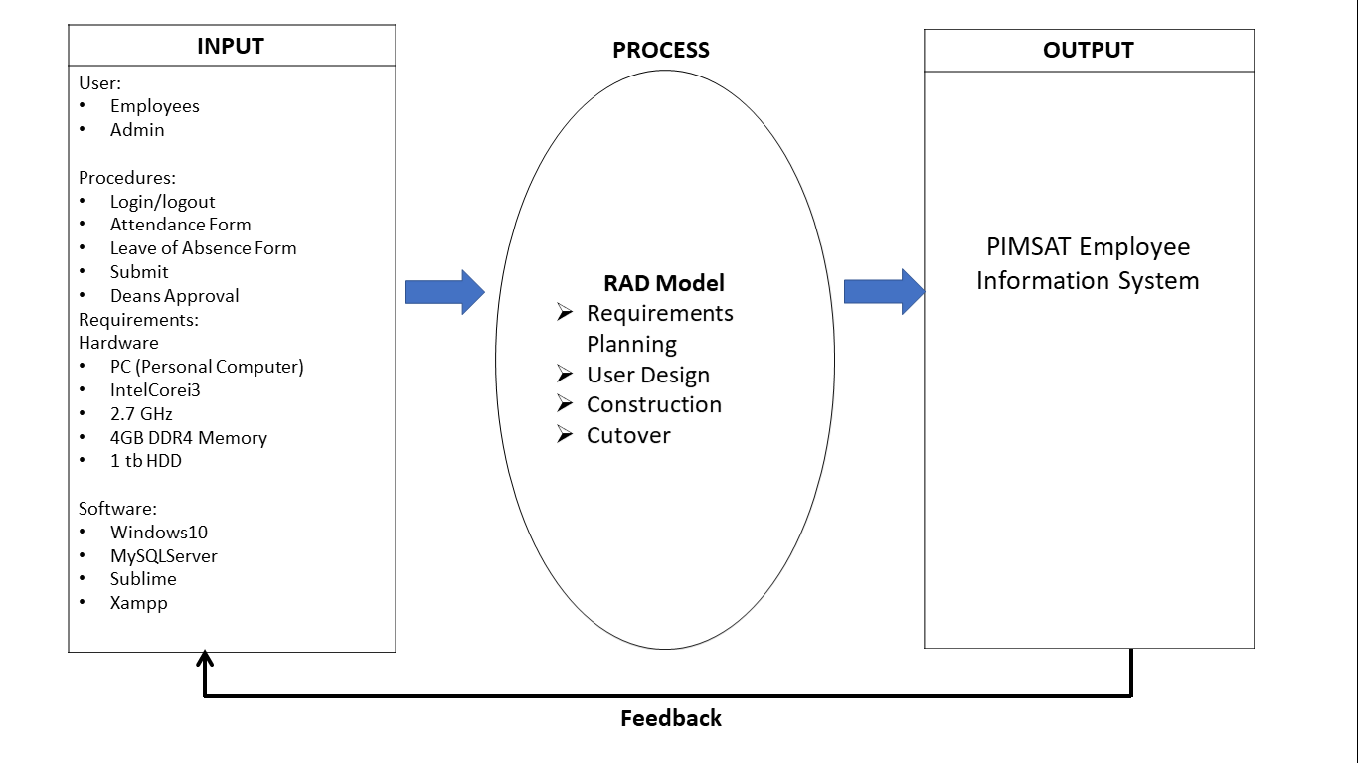

The Input,Process,Output (IPO). It is the process of accepting data or information from a user, and it allows a computer to perform any task by employing input.

The INPUT has a two part the user that can open and manage the system and the procedure that the user can follow as a guide. The PROCESS is a way to understand the method that they give of the sudy. While the OUTPUT is the PIMSAT Employee Information System that the user can be used.

**Dataflow Diagram (DFD)**

Data flow diagrams, often known as DFDs, are used to graphically illustrate data flow in a corporate information system. DFD denotes the steps involved in transferring data from the input to file storage and report production in a system. A data flow diagram (DFD) depicts how information flows through a process or system. It shows data inputs, outputs, storage sites, and paths between each destination using predetermined symbols such as rectangles, circles, and arrows, as well as short text labels. Data flowcharts can range from simple, even hand-drawn process overviews to multi-level, in-depth DFDs that go deeper into how data is processed. They can be used to examine a current system or to create a new one.

The researchers will use DFD because The functions, or processes, that capture, manipulate, store, and distribute data between a system and its environment, as well as between system components, are visually represented by the DFD. It's a useful communication tool between the user and the system designer because of the visual representation. DFD's structure allows you to start with a broad overview and work your way down to a hierarchy of specific diagrams.

**Dataflow Diagram (DFD)**

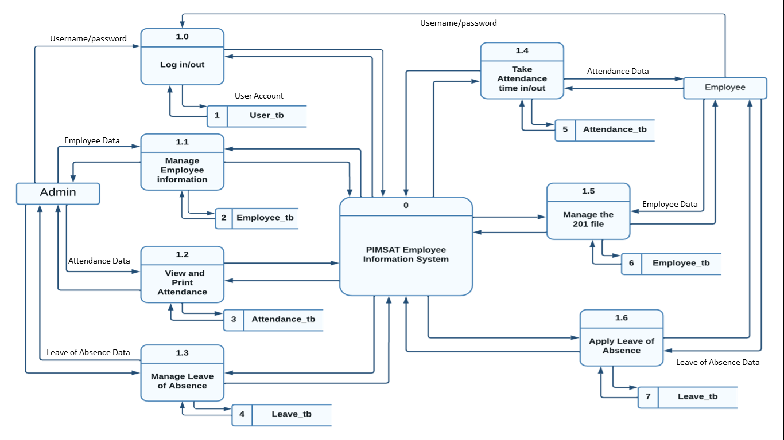

In figure 3 it shows the data flow diagram where in the process of PIMSAT Employee Information System. The Admin can  log in to the account direct to the system. Besides, the admin manages the employee information and admin also can view and print the attendance of the employee. The admin can manage also the leave of absence and select the application leave status of the employee if it is approve or disapprove.

In the other hand the employee can also go to the system and log In in order to take an attendance where in it will be recorded direct to the system that the admin will see the attendance information by the employee. The employee can also manage their 201 file. Also the employee can submit or apply leave of absence and they will know if their application is approve or disapprove once they log in again to their account and said the application was approved or disapproved.

**Entity Relationship Diagram (ERD)**

An entity relationship diagram (ERD) is a type of flowchart that illustrates how “entities” such as people, objects or concepts relate to each other within a system . An ER model is a design or blueprint of a database that can later be implemented as a database. The main components of ER model are: entity set and relationship set.

An ER diagram shows the relationship among entity sets. An entity set is a group of similar entities and these entities can have attributes. In terms of DBMS, an entity is a table or attribute of a table in database. So by showing relationship among tables and their attributes, ER diagram shows the complete  logical structure of a database.

The researchers use ERD because they assist us in visualizing how data is connected in a broad sense, and are especially valuable when building a relational database.

**Entity Relationship Diagam of PIMSAT Employee Information System**

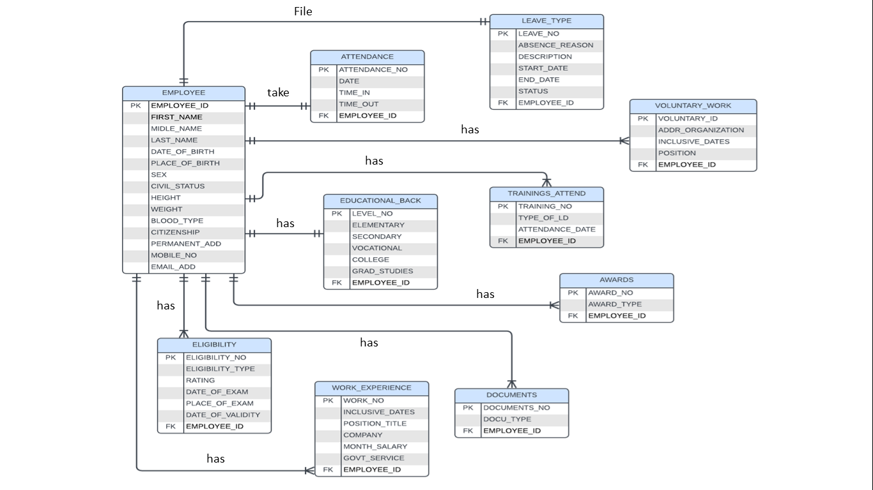

An Entity Relationship Diagram (ERD) contains entities and attributes, in the following diagram the researchers have (10) entities:

Employee,Attendance,Leave_type,Voluntary_work,Trainings_attend,Educational_back,Awards,Eligibility,Work_experience,Documents and their relationship. The relationship between  employee and attendance is one to one. The relationship between  employee and leave_type is one to one. The relationship between employee and voluntary_work is one to many. The relationship between employee and trainings_attend is one to many. The relationship between employee and educational_back is one to one. The relationship between employee and awards is one to many. The relationship between employee and eligibility is one to many. The relationship between employee and work_experience is one to many. Also the relationship between employee and documents is one to many.